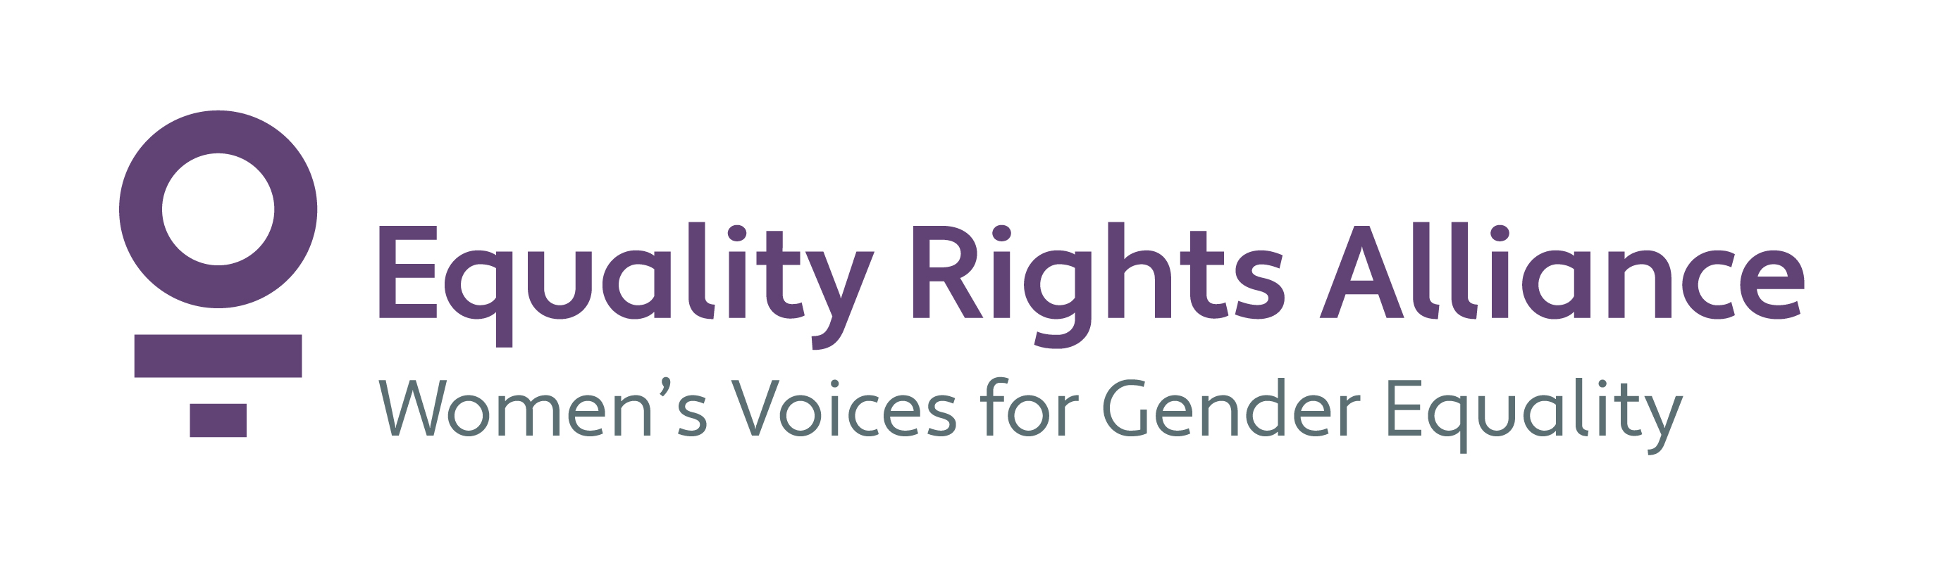
Submission of Equality Rights Alliance to the inquiry of the Senate Standing Committee on Community Affairs into the Paid Parental Leave Amendment (Flexibility Measures) Bill 2020

6 March 2020

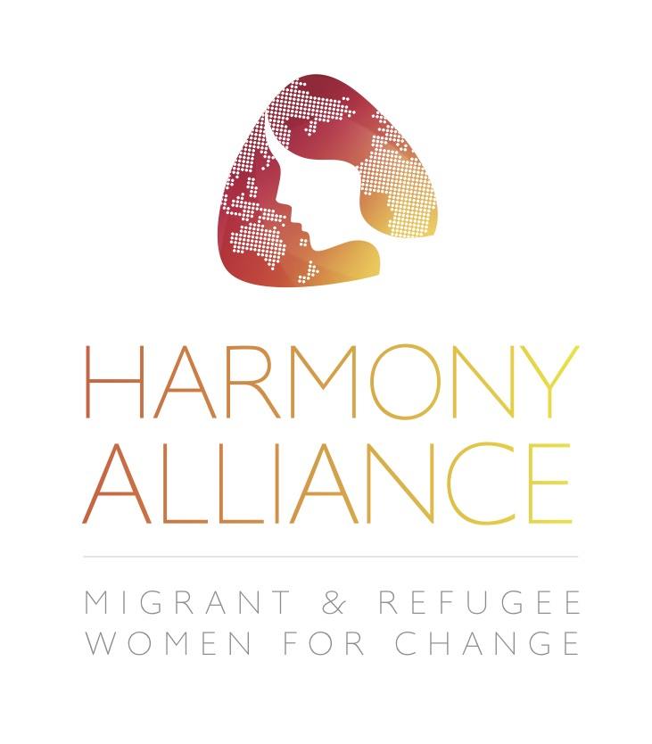
This submission is endorsed by
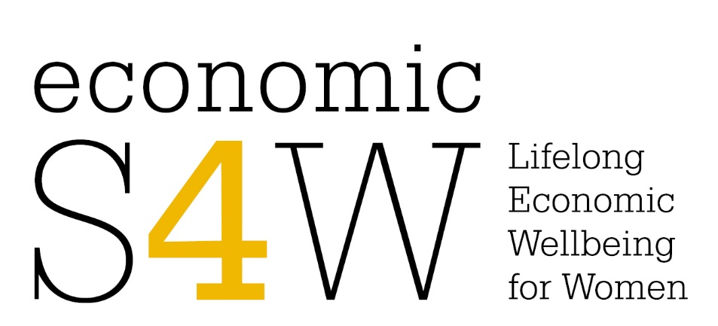
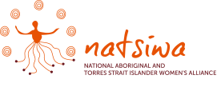
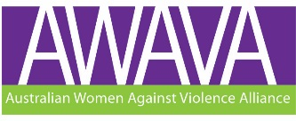

This submission is endorsed in whole or part by

- Aboriginal Legal Rights Movement
- Alevi Federation of Australia
- Amnesty International Australia
- Australasian Council of Women and Policing
- Australian Baha'i Community - Office of Equality
- Australian Centre for Leadership for Women
- Australian Council for International Development Gender Equity Working Group
- Australian Federation of Medical Women
- Australian Graduate Women
- Australian Motherhood Initiative for Research
- and Community Involvement
- Australian Women's Health Network
- CARE Australia
- Children by Choice
- COTA
- Federation of Ethnic Community Councils of Australia
- Feminist Legal Clinic
- Fitted for Work
- Girl Guides Australia
- Good Shepherd Australia New Zealand
- Homebirth Australia
- Human Rights Law Centre
- Immigrant Women's Speakout Association NSW
- International Women's Development Agency
- JERA International
- Jessie Street National Women's Library
- Justice Connect
- Marie Stopes Australia
- Maternity Choices Australia
- Migrant Women's Lobby Group of South Australia
- National Association of Services Against Sexual Violence
- National Council of Churches Gender Commission
- National Council of Jewish Women of Australia
- National Council of Single Mothers and their Children
- National Council of Women of Australia
- National Foundation for Australian Women
- National Older Women's Network
- National Union of Students Women's Department
- NSW Council of Social Service
- Project Respect
- Public Health Association of Australia - Women's Health Special Interest Group
- Reproductive Choice Australia
- Safe Motherhood For All
- Sisters Inside
- Soroptimist International
- UN Women National Committee Australia
- Union of Australian Women
- United Nations Association of Australia Status of Women Network
- Victorian Immigrant and Refugee Women's Coalition
- VIEW Clubs of Australia
- Women in Adult and Vocational Education
- Women in Engineering Australia
- Women on Boards
- Women Sport Australia
- Women with Disabilities Australia
- Women's Electoral Lobby Australia
- Women's Equity Think Tank
- Women's Housing Ltd
- Women's Information Referral Exchange
- Women's International League for Peace and Freedom
- Women's Legal Services Australia
- Women's Property Initiatives
- Working Against Sexual Harassment
- YWCA Australia
- Zonta International Districts 22, 23 and 24

Equality Rights Alliance
Equality Rights Alliance (ERA) is Australia’s largest network advocating for women’s equality, women’s leadership and recognition of women’s diversity. We bring together 64 non-government organisations and social enterprises with a focus on the impact of policy or service delivery on women.
We are one of the six National Women’s Alliances, funded by the Commonwealth Office for Women.
We thank you for the opportunity to make this submission. We have outlined 33 recommendations to advance gender equality across a number of areas covering gender aware policies and processes, housing affordability, income support and economic security, education, health, feminist foreign policy and women, peace and security.

Summary of Recommendations:
- Support the Paid Parental Leave Amendment (Flexibility Measures) Bill 2020, with consideration given to the need for modifications regarding Section 190A and eligibility for flexible PPL days for primary carers having recently finished a Newly Arrived Resident Waiting Period.

- Investigate mechanisms and reform to achieve greater gender balance in the uptake of PPL as part of a broader review of PPL.
- Total Commonwealth supported Paid Parental Leave (including continuous and flexible leave periods), should be extended to 26 weeks for the primary carer.
- Dad and Partner Payment should be extended to 4 weeks.
- Add the phrase “under this legislation” to Section 190A(1) to read “If a person owes a debt to the Commonwealth under this legislation,…”.
- The Secretary must have a discretion to halt or reduce deductions in cases of hardship or where reclaiming the funds owed would be inconsistent with the aims of the Act.
- Amend Section 31AA so that both primary and secondary claimants are eligible for parental leave pay in the flexible PPL period for the child, if the flexible PPL period is after a newly arrived resident’s waiting period to avoid indirectly discriminating against women.
- Expand eligibility for the Paid Parental Leave scheme to include people currently subject to a NARWP.
- Extend and fund the Superannuation Guarantee to the statutory Paid Parental Leave scheme. PPL should be strengthened to ensure the superannuation guarantee is included in the Government scheme and any supplemental income provided by employers during periods of parental leave.
- The Secretary must have discretion to waive the work test in determining eligibility for PPL in cases where the claimant has been forced to take unpaid leave or unfairly dismissed as a result of a pregnancy.

Introduction: Australia’s international human rights obligations
Through international human rights frameworks, Australia has committed to a gender-responsive approach to social security and protections, which seeks to respond to and transform those inequalities between women and men which render women more vulnerable to poverty. Paid Parental Leave (PPL) is a crucial component of gender-responsive social security.
The right to social security is set out in article 9 of the Convention on Economic, Social and Cultural Rights, to which Australia is a signatory. Article 9 is significant, because it establishes social security as a human right, as opposed to an optional grant or endowment by States.
Under the Convention on the Elimination of Discrimination Against Women, Australia commits to “take all appropriate measures to eliminate discrimination against women in all matters relating to marriage and family relations and in particular shall ensure, on a basis of equality of men and women…” and “take all appropriate measures to eliminate discrimination against women in the field of employment… in particular… the right to social security”. Further, under Goal 5 of the Sustainability Development Agenda, Australia commits to:
recognize and value unpaid care and domestic work through the provision of public services, infrastructure and social protection policies and the promotion of shared responsibility with the household…
In early 2019, the sixty-third session of the UN Commission on the Status of Women (CSW63) negotiated Agreed Conclusions on the theme of social protection systems, public services and sustainable infrastructure for gender equality and the empowerment of women and girls. In adopting the conclusions, Australia agreed to:
Ensure the right to social security in national legal frameworks, as well as ensure universal access to social protection, supported by national strategies, policies, action plans and adequate resources, to enhance gender equality and the empowerment of women and girls;
Australia has also made significant commitments to social protections for unpaid work and carers, including mothers, older women, and on welfare conditionality. Under the 2030 Sustainable Development Agenda, Australia committed specifically to social protection schemes which support unpaid workers and carers, with a view to recognising and valuing unpaid work and care:
Ensure access to social protection for unpaid caregivers of all ages, including coverage for health care and pensions, and in this regard strengthen social protection schemes that promote, as appropriate, the economic, social and legal recognition of unpaid care and domestic work..;
In the Australian context, PPL is a key social protection scheme that promotes the economic, social and legal recognition of unpaid care and domestic work, in which women are overrepresented.

Paid Parental Leave Amendment (Flexibility Measures) Bill 2020
ERA welcomes the Paid Parental Leave Amendment (Flexibility Measures) Bill 2020. PPL is recognized as a crucial measure for progressing gender equality, and in the implementation of the Convention on the Elimination of All Forms of Discrimination against Women. ERA is broadly supportive of the Bill, and its intended aim of increasing women’s workforce participation and options for women and carers in accessing paid parental leave.
In framing our comments, ERA notes that while the scheme allows same gender couples and men to access primary parental leave, it is important to note that 95% of primary parental leave is taken by women and so the scheme is clearly gendered. As a result, women are considered the primary referent of the scheme for the purpose of this submission. Nonetheless, workforce participation for women with dependent children is increasing. We note that according to WGEA, with
“…women’s increasing workforce participation and the decline of the male breadwinner model it is likely that gender-specific specialisations around unpaid care and paid work are slowly disappearing. To accommodate these changes it requires some changes in workplaces, including access to flexible working and parental leave”.
A broader review of PPL is required to investigate how greater gender balance in unpaid work and paid parental leave could be achieved.
According to data from HILDA, unpaid work distribution in heterosexual couples is shared relatively equally, prior to having a first child. Following the birth of a first child, the prime load of unpaid care shifts to the female partner. PPL is therefore a critical opportunity to redistribute unpaid caring responsibilities across genders and establish a more equal distribution of unpaid care within the family unit. We must shift PPL from being a maternity/primary carer entitlement only and transition PPL to a sharable family entitlement with incentives to encourage men to take a significant part of the total leave entitlement. There is increasing evidence indicating that equitable sharing of parental leave contributes to increasing women’s workforce participation, one of the Commonwealth’s priorities for women, including from OECD countries Sweden and Germany. The Bill contributes to this aim by increasing the flexibility by which parents and carers can utilise PPL to support their workforce participation, and share PPL between primary and secondary carers. Nonetheless, a broader review of mechanisms, such as employer standards and contributions, is needed.
Recommendations:
- Support the Paid Parental Leave Amendment (Flexibility Measures) Bill 2020, with consideration given to the need for modifications regarding Section 190A and eligibility for flexible PPL days for primary carers having recently finished a Newly Arrived Resident Waiting Period

- Investigate mechanisms and reform to achieve greater gender balance in the uptake of PPL as part of a broader review of PPL

Increasing Paid Parental Leave
The potential to increase the capacity of parents to share paid parental leave (PPL) is welcome, and increasing flexibility by allowing secondary carers to take on a greater share of caring and leave is a positive improvement. However, we note that Australia’s PPL scheme remains one of the least generous in the OECD. The Productivity Commission’s 2009 report on PPL noted that there is a considerable body of evidence to support the benefits of primary carer leave for the developmental health of the child. The report noted that longer periods of parental leave are associated with improved infant health outcomes and lower rates of infant mortality and the importance of primary carers for early brain development. In quoting the OECD, the Productivity Commission noted that
“Taking stock of the evidence, it seem that child development is negatively affected when an infant does not receive full-time personal care (breastfeeding issues aside…) for at least the first 6 to 12 months of his/her life.” (OECD, 2007: 110-111, as quoted in Productivity Commission, 2009: 4.41)
Further, for women and parents who wish to breastfeed, the World Health Organization’s guidelines recommend 26 weeks of leave for optimal infant breastmilk feeding. There is therefore considerable evidence to support the extension of paid parental leave to 26 weeks. While some parents receive 26 weeks of leave through a combination of Commonwealth and workplace-support entitlements, this is not the case across all sectors of workplace. 26 weeks of leave should therefore be provided under the Commonwealth scheme to ensure equality of access.
The Workplace Gender Equality Agency (WGEA) notes that uptake of parental leave by fathers in Australia is low, but that use increases internationally when entitlements are flexible, and when entitlements are generous. The uptake of parental leave by fathers and secondary carers has been shown to support more gender equitable sharing of caring responsibilities within families, through which women’s workforce participation is supported. This is aligned with the aims of the this Bill and the Commonwealth’s broader priorities for women. While this amendment increases the flexibility of parental leave payments, it does not address generosity of payments as a supporting factor. While Australia entitles father or secondary carers to 2 weeks of Dad and Partner Payment (DAPP), under the world-leading scheme in Sweden each parent is entitled to an exclusive 90 days or 18 weeks of paid parental leave under a ‘use it or lose it’ basis, with the intention of encouraging fathers to increase their involvement in care. Similarly, Iceland enacted a scheme of 18 weeks non-transferrable father and partner leave in 2000. Recent research on the scheme showed a correlation between the length of leave taken by fathers and their involvement in care work after the leave period. Increasing the DAPP is therefore a crucial step in promoting gender equality and women’s workforce participation by encouraging the sharing of caring responsibilities by both parents during and after the parental leave period. We refer the Committee to the call for a review of the Paid Parental Leave scheme by the National Foundation of Australian Women (NFAW), who recommend extension of the DAPP to 4 weeks to extended men’s participation in care.
Recommendations:
- Total Commonwealth supported Paid Parental Leave (including continuous and flexible leave periods), should be extended to 26 weeks for the primary carer
- Dad and Partner Payment should be extended to 4 weeks

Debt recovery
ERA is concerned by the addition of provisions from Section 190A and subsection 69B which give the Secretary the power to automatically deduct amounts from future instalments of PPL to pay down debts owed to the Commonwealth. ERA recognizes the appropriateness of deducting amounts from future payments due to overpayments from a failure to notify of changes to a claimant’s eligibility on a flexible PPL day. However, we are concerned that current wording of the Bill allows the Secretary to deduct debts that are owed to the Commonwealth but which have not arisen under this legislation. Such an approach is not consistent with either the aims of the Bill or social security as a human right.
Pregnancy, and the period following the birth of a child, can be a period of increased stress for parents and susceptibility to harm for women. It can coincide with perinatal depression and gendered violence. Indeed, women and pregnant people are at an increased risk of violence during pregnancy. Research shows that the initial onset of domestic violence is often during pregnancy, or if violence was already being perpetrated, will increase in severity during pregnancy and into the first month after the birth of a child. The impact of debts would be exacerbated by economic or other hardship such as experiencing violence, and will therefore have the greatest negative impact on women and infants most in need of social protection floors. Requiring women to contest debts already deducted from their leave income, and on which they may be reliant for the immediate health and wellbeing of an infant, is not consistent with the Bill’s aims of increasing flexible options for women and primary carers, or of supporting their return to work.
Recommendation:
- Add the phrase “under this legislation” to Section 190A(1) to read “If a person owes a debt to the Commonwealth under this legislation,…”
- Amend the Bill to give the Secretary discretion to halt or reduce deductions in cases of hardship or where reclaiming the funds owed would be inconsistent with the aims of the Act.

Sections 31AA and 31AB for Claimaints subject to a Newly Arrived Residents Waiting Period (NARWP)
Sections 31AA and 31AB lay out the criteria for eligibility and ineligibility for parental leave pay on a flexible PPL day for a child. ERA does not support restrictions to eligibility for PPL arising from NARWPs and notes the considerable benefits of parental leave to infants. Further, the eligibility criteria for a claimant subject to a NARWP creates indirect discrimination in access to PPL for women and men. Under Section 31AB, secondary claimaints, who are predominantly men, are eligible for flexible PPL days if they are not subject to a NARWP on the day in question, even if they were subject to a NARWP at the time of the birth of the child to which the payment relates. In contrast, primary claimaints, who are predominantly women, would not be eligible for flexible PPL days if they were subject to a NARWP at the time of the birth of the child, even if the NARWP had finished on the flexible PPL day in question.
Raising children is not a gender equitable process in Australia. As noted above, 95% of people taking primary parental leave are women. Further, in 2019 far fewer women were employed (62% of women compared to 90% of men) when the family’s youngest dependent was 0-4 years. Conequently, the different eligibility requirements for primary and secondary carers in cases involving a NARWP indirectly discriminate against women, as women are far more likely to be primary carers than men.
In this way, eligibility requirements for flexible PPL days then serve to reinforce gender inequitable roles which disadvantage women in the workforce and their economic security by creating additional barriers for accessing PPL for women/primary claimaints compared to men/secondary claimants. Therefore, the intersections of the PPL amendments and migration law coincide to multiply the disadvantage and relative gender inequality experienced by migrant women in Australia..
Recommendation:
- Amend Section 31AA so that both primary and secondary claimants are eligible for parental leave pay in the flexible PPL period for the child, if the flexible PPL period occurs after a newly arrived resident’s waiting period has expired to avoid indirectly discriminating against women.
- Expand eligibility for the Paid Parental Leave scheme to include people currently subject to a NARWP.

Broader considerations
Superannuation Guarantee
PPL should be strengthened to ensure the superannuation guarantee is included in the government statutory scheme. As Women in Super highlights, “it is unfair and discriminatory in modern Australia that the one type of leave directed predominantly at women does not include superannuation guarantee payments.” The failure to include superannuation guarantee for PPL has flow-on impacts on the relative economic disadvantage of older women. In 2017-2018, the median superannuation balance for older women aged 55-64 was $118,556, in comparison with $183,000 for men of the same age. The Productivity Commission’s 2009 report into Paid Parental Leave recommended the eventual inclusion of superannuation into PPL and the 2013 Australian Human Rights Commission report Investing in Care offered the extension of the superannuation guarantee to PPL as an option for reform.
Recommendation:
- Extend and fund the Superannuation Guarantee to the statutory PPL scheme. PPL should be strengthened to ensure the superannuation guarantee is included in the Government scheme and any supplemental income provided by employers during periods of parental leave

Discretion for work test eligibility requirements
Under the current scheme, primary carers must satisfy the work test for eligibility, meaning they must work or have worked 10 out of the previous 13 months prior to the birth of the child in order to be eligible for PPL. Women and pregnant people who are dismissed or placed on unpaid leave due to their pregnancy are not only unfairly denied employment but are then positioned to fail to satisfy the work test for eligibility for PPL. This means that women and pregnant people are not eligible for the PPL simply because of their employer's refusal to provide paid safe work leave or as a unlawful dismissal because of pregnancy. Given the stated aims of this Bill and the government’s goal of increasing women’s workforce participation and economic security, the PPL scheme should allow for such circumstances and provide for discretion in the determination of eligibility.
Recommendation:
- The Secretary must have discretion to waive the work test in determining eligibility for PPL in cases where the claimant in question has been forced to take unpaid leave or unfairly dismissed as a result of a pregnancy

Convention on the Elimination of All Forms of Discrimination Against Women – Part II, (Art.11.1, (e)), A/RES/34/180, available at https://www.ohchr.org/en/professionalinterest/pages/cedaw.aspx
General Assembly, Transforming our world: the 2030 Agenda for Sustainable Development - Goal 5. Achieve gender equality and empower all women and girls, (5.4), A/RES/70/1, available at https://www.un.org/en/ga/search/view_doc.asp?symbol=A/RES/70/1&referer=http://www.un.org/en/documents/index.html&Lang=E
United Nations Economics and Social Council, Commission on the Status of Women Sixty-third Session – Strengthen normative, legal and policy frameworks, (para.47, (f)), E/CN.6/2019/L.3/, available at https://undocs.org/en/E/CN.6/2019/L.3
ibid para.47, (l)
UN Women (2019) Progress of the World’s Women 2019-2020: Families in a Changing World, US: UN Women, available from: https://www.unwomen.org/-/media/headquarters/attachments/sections/library/publications/2019/progress-of-the-worlds-women-2019-2020-en.pdf?la=en&vs=3512, accessed 27 February 2020.
Newsome, L. (2020) ‘Parental Leave scheme marred by 1950s sentimentality’, Broad Agenda, 19 February 2020, available from: http://www.broadagenda.com.au/home/leave-scheme-marred-by-1950s-sentimentality/, accessed 27 February 2020.
Australian Burea of Statistics (ABS), (2017) ‘Media Release: One in 20 dads take primary parental leave’, 4125.0 – Gender Indicators, Australia, Sep 2017, Canberra: Commonwealth of Australia, available from: https://www.abs.gov.au/ausstats/abs@.nsf/Lookup/by%20Subject/4125.0~Sep%202017~Media%20Release~One%20in%2020%20dads%20take%20primary%20parental%20leave%20(Media%20Release)~11, accessed 27 February 2020.
Workplace Gender Equality Agency (WGEA), (2018). Insight paper – Towards gender balanced parental leave: Australian and international trends. NSW: Commonwealth of Australia, available from: https://www.wgea.gov.au/sites/default/files/documents/gender%20balanced%20parental%20leave.pdf, accessed 27 February 2020.
Inga Lass, “Who is doing what on the homefront?” Pursuit UniMelb. 31 July 2018 https://pursuit.unimelb.edu.au/articles/who-is-doing-what-on-the-homefront (accessed 18/10.18)
Workplace Gender Equality Agency, Towards gender balanced parental leave – Australian and international trends Insight Paper (Sydney: Australian Government, 2017).
Ibid.
World Health Organization (WHO), (2011) Exclusive breastfeeding for six months best for babies everywhere, NP: WHO, available from: https://www.who.int/mediacentre/news/statements/2011/breastfeeding_20110115/en/, accessed 27 February 2020.
Workplace Gender Equality Agency (WGEA), (2018).
Arnalds, A., Eydal, G., and Gislason, I. (2013) ‘Equal rights to paid parental leave and caring fathers – the case of Iceland’, Icelandic Review of Politics and and Administration, 9(2): 323-344, available from: https://search.proquest.com/openview/826617aef6fac104301ec237ce1b87a1/1?pq-origsite=gscholar&cbl=2032137, accessed 27 February 2020.
NFAW, (2018) NFAW Believes its Time for a Stocktake of the Parental Leave Payment (PLP), available from: https://nfaw.cdn.prismic.io/nfaw%2F0a00aec2-dc5e-4161-ba04-f69b1cb1e631_paid+parental+leave+1nov.2018.pdf, accessed 27 February 2020.
Campo, M. 2015, ‘Domestic and family violence in pregnancy and early parenthood: Overview and emerging interventions’, CFCA Practitioner Resource - December 2015, Victoria: Australian Institute of Family Studies, available from: https://aifs.gov.au/cfca/publications/domestic-and-family-violence-pregnancy-and-early-parenthood, accessed 26 February 2020
Australian Bureau of Statistics (ABS), 2019. 6224.0.55.001 – Labour Force, Australia: Labour Force Status and Other Characteristics of Families, June 2019: Couple Families, Canberra: Commonwealth of Australia, available from: https://www.abs.gov.au/ausstats/abs@.nsf/Latestproducts/6224.0.55.001Main%20Features4June%202019?opendocument&tabname=Summary&prodno=6224.0.55.001&issue=June%202019&num=&view=, accessed 26 February 2020.
Women in Super, “2018-19 Pre-Budget Submission” Women in Super Submissions and Discussion Papers, 14 December 2017, https://clarety-wis.s3.amazonaws.com/userimages/WIS%20Submissions/Women%20in%20Super%202018-19%20Pre-Budget%20Submission.pdf (accessed 18.10.18)
Cerise, Somali, et al., 2009. Accumulating poverty? Women’s experiences of inequality over the lifecycle. Sydney: Australian Human Rights Commission (AHRC).
Australian Bureau of Statistics (ABS), (2019). 4125.0 – Gender Indicators, Australia, Nov 2019, https://www.abs.gov.au/ausstats/abs@.nsf/Lookup/by%20Subject/4125.0~Nov%202019~Main%20Features~Economic%20Security~4 (accessed 20/01/2020).
Australian Human Rights Commission, Investing in Care: Recognising and valuing those who care Volume 1-Research Report (Sydney, 2013), 15.

