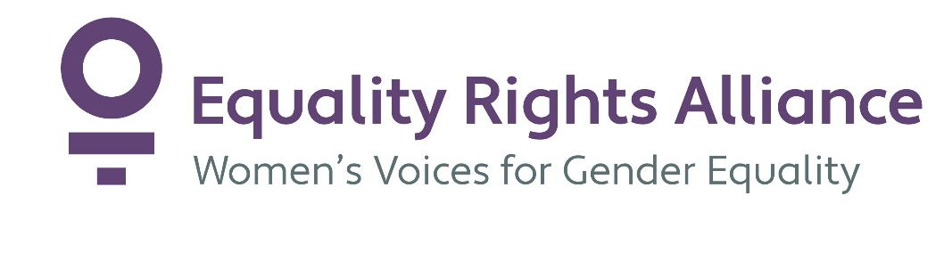

Pre-Budget Submission of the Equality Rights Alliance
20 December 2017

Equality Rights Alliance
Equality Rights Alliance (ERA) is Australia’s largest network advocating for women’s equality, women’s leadership and recognition of women’s diversity. We bring together 64 non-government organisations and social enterprises with a focus on the impact of policy or service delivery on women.
We are one of six National Women’s Alliances, funded by the Commonwealth Office for Women.
We thank you for the opportunity to make this submission. We have outlined 14 recommendations to advance gender equality across a number of areas covering gender aware policies and processes, housing affordability, income support, education, health and international development.
The Sustainable Development Goals
The 2030 Agenda is comprised of the 17 Sustainable Development Goals, a transformational roadmap for the planet, peace and prosperity. The SDGs have been in train since multilateral agreement in September 2015 and, unlike the Millennium Development Goals, apply universally. The achievement of gender equality is a standalone goal and an essential pre-condition of the remaining 16 goals. The 2030 Agenda is not just a shared vision for the world’s governments, but a point of unity for Australia’s local, state, territory and federal governments. To this end, implementation of the goals domestically with the requisite monitoring and reporting must be demonstrated through alignment of budgetary measures to the Sustainable Development Goals and their respective targets.
Recommendation:
- The Federal Budget must include reporting of Budget measures against the 17 Goals of the Sustainable Development Agenda.

Gender Responsive Budgeting
Gender responsive budgeting advances gender equality by:
- tracking government expenditure to improve accountability and transparency for the government’s gender equality goals, in line with our SDG commitments;
- recognising and making visible differential impacts across genders of all budgetary measures;
- comprehensively linking policies across areas through a gender equality lens to break down policy incoherences and siloes on gender equality;
- using this analysis to ultimately influence budgetary decision-making so as to limit the negative impacts on women of revenue or expenditure measures and identify measures to advance gender equality.
A gendered analysis of the Budget is required to implement the Government’s gender equality commitments of increasing women’s safety, strengthening women’s economic security and supporting more women into leadership. Gender budgeting should “eradicate gender asymmetry in budgets” (Ng, 2016) by covering expenditure and revenue measures. This process should include analysis of the investment required to achieve gender equality in Australia in order to translate gender equality goals into budgetary commitments (Sharp in Ng, 2016). It is critical gender analysis is incorporated into the tax and transfer measures to identify and address differential impacts across genders and remove tax settings that exacerbate gender inequality.
In line with our Goal 5 commitments under the 2030 Agenda, the Australian Government must commit to a process of gender budgeting throughout the budget cycle, which is engaged with civil society, participatory and part of a revitalised gender machinery within Government. Without this process, the Budget risks embedding and exacerbating gender inequalities and remains an untapped opportunity to advance gender inequality.
Recommendation:
- Investigate and consult on models of gender responsive budgeting for integration into the budget process.

Increasing gender responsiveness and awareness in budgeting
Counting, recognising and valuing unpaid work
ERA draws attention to the pre-budget submission from economic Security 4 women, outlining the pressing need for time-use data collection:
Australia is long overdue for a time use survey (TUS). The last TUS was undertaken in 2006. Since then Australia’s population has grown 18.4% plus labour force participation patterns, conventional market and nonmarket economies have been in transition while people are spending longer periods in education. Australia is being left behind in the international community which readily collects time use data to enhance decision-making in numerous areas such as employment, education and health.
The 2016 Census offers an indication of the disproportionate share of unpaid domestic work that women undertake, with women shouldering 5-14 hours of housework a week and men less than 5 hours a week (Ruppanner, 2017). And while these data offer a snapshot of the unequal distribution, it is by no means a reliable or comprehensive statistical picture of time-use. Time-use surveys are the only accurate record of unpaid work, providing crucial data enabling policy analysis critical across a number of policy areas.

The effectiveness of gender budgeting rests heavily on robust, relevant data on the unpaid work that underpins all economic activity.

Recommendation:
3. Secure the future of systematic time-use data collection through a funded time-use survey in 2018-19 and beyond at regular intervals.

Health care and social assistance represents some of the largest and fastest growing employment sectors in Australia with over 1.4 million workers (ABS, 2014). The sectors are feminised with women representing 79.2 per cent of the work force. (WGEA, 2016). The systematic, social under-valuing of care work through gender-based stereotyping and gender-based occupational segregation is a key driver of the gender pay gap (Senate Finance and Public Administration Committee, 2017). The 2015 Senate Report into gender-based occupational segregation found that women in female-dominated industries earn, on average, almost $40 000 less than the average full-time total remuneration of a man in a male-dominated industry (Senate Finance and Public Administration Committee, 2017). The Government’s own strategy to boost women’s workforce participation, Towards 2025, identifies the growth in the care economy as “an opportunity to reduce gender segregation” (Australian Government, 2017). However, WGEA has found that, in recent years, the proportion of women in health care and social assistance has increased further (WGEA, 2016).
The projected growth in the sector demands that this work is commensurately valued and paid accordingly. The relationship between the unequal gendered division of unpaid care work and endemically low pay rates in the paid care workforce must be examined. A key consideration in redistributing unpaid care work more evenly across genders, is to reduce this work through the universal provision of social infrastructure by governments. Additionally, it is essential that the impacts of the current agenda to marketise human services, including through possible downward pressure on wages and conditions, on the gender pay gap are fully understood (Allebone, 2011). These issues raise the question of how Australia can deliver the best health care and social assistance services into the future, to meet growing need in a way that advances gender equality, rather than exploits the under-valuing of work traditionally assigned to women.
Recommend:
- Task the Productivity Commission to inquire into the social and economic valuing of the paid care workforce (including but not limited to the health care and social assistance sectors) with a view to reducing the gender pay gap and increasing women’s economic security.

Equal Access to Housing for Women
Access to and rights over housing are shaped by gender. Women’s experiences of economic inequality, marked by the over-representation of women in key poverty indicators and the gender wealth, income and retirement gaps, combine with an increasingly unaffordable housing market to undermine the position of women in housing systems. Compounding this is the impact of violence, specifically domestic and family violence, on women’s experiences of housing. Issues relating to economic inequality, violence and unequal distribution of caring responsibilities represent a set of challenges specific to gender which reveal both the gendered dimensions of housing stress and homelessness and the need for solutions which are gender responsive.
Strong, effective housing support systems are critical to women’s housing wellbeing. This is demonstrated in the data which show women are the primary beneficiaries of housing support, assistance and services - making up the majority of public housing tenants (AIHWa, 2017), Commonwealth Rent Assistance (CRA) recipients (DSS, 2017) and people approaching specialist homelessness services (AIHWb, 2017).

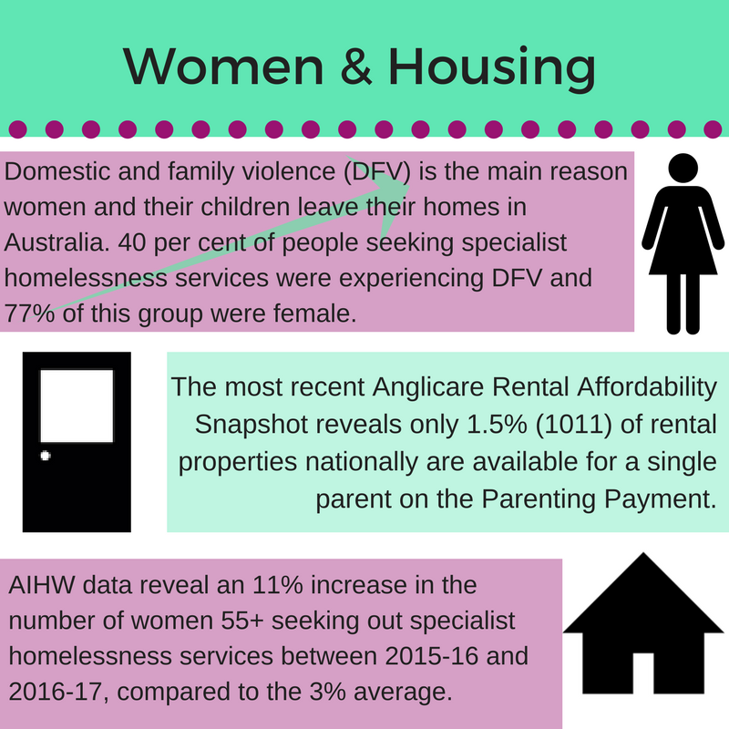
(AIHW, 2017 and Anglicare Australia, 2017)

Invest in long-term, permanent housing

Nothing less than a system-wide shift to long-term, permanent housing solutions driven by Government investment is needed to address Australia’s chronic housing affordability problems. A significant boost in the affordable housing supply for people on the lowest incomes is needed to address the greatest housing need (AHURI, 2017). Long-term, permanent housing is the greatest gap in specialist homelessness services provision with only 5% of long-term housing need able to be met (AIHWb, 2017). An absence of affordable rental housing is consistently raised as a barrier limiting the effectiveness of tenancy advice and programming (Tually et al, 2016). Access to permanent affordable accommodation is considered by specialist homelessness services as a priority area for additional funding (Flatau et al, 2017). The Committee for Economic Development of Australia has recently reported that, at a minimum, an additional 10 000 social rental and 10 000 affordable rental dwellings are required to prevent the housing shortage further deepening (CEDA, 2017). Increasing affordable housing supply for people on low-incomes is critically linked to a swathe of policy areas, particularly to advance gender equality, including the Third Action Plan to Reduce Violence Against Women which includes an unequivocal commitment to increase social housing:

Increase the stock of affordable, accessible and social housing and the support needed to enable women and their children, if they want to, to stay in their own homes through Safe at Home initiatives (DSS, 2016).

ERA welcomes a revitalised National Housing and Homelessness Agreement (NHHA) that guarantees longer-term funding with indexation for homelessness services. However, the significant limitations of the NHHA to deliver increased supply must be recognised. There is a risk that the NHHA is seen as the primary vehicle to increase housing affordability in Australia, however, this is impossible without a capital funding component or a national housing strategy attached that puts to work all of the federal government’s levers. The need to develop a national housing strategy and a process to determine and calculate needed supply is required to set supply goals to meet existing and projected need. Further, the funding framework for specialist homelessness services must recognise the expertise and experience of non-government services and the need to promote service sectors that are diverse in organisational form and focus. This would ensure funding for services with the gender expertise required to respond to women’s housing issues. Increased transparency to track the exact quantum of funding to gendered services, including specialist women’s services would improve accountability on this front.

Recommendation:

- Develop a gender-responsive national housing strategy that encompasses all of the Federal Government’s levers. Increase NHHA funding for social housing supply with a capital component. Increase transparency of the NHHA to include clear tracking of funding to all specialist homelessness services.

ERA welcomes the National Housing Finance and Investment Corporation, recognising the bond aggregator as a critical measure to increase housing supply. It is vital that the bond aggregator is understood as part of an overall housing affordability response to generate supply. The Senate’s 2015 majority report into housing affordability made it clear that housing supply bonds are complementary and must fit into a broader housing strategy and not replace existing government funding for social housing (Senate Economics References Committee, 2015). In order to generate housing for people on the lowest incomes and in the greatest housing need, the bond aggregator must be underpinned by additional resources to cover the financing gap (CEDA 2017). The public subsidy or direct government investment required to bridge this funding gap could take a number of forms “including through examining the levels of direct subsidy needed for affordable low-income rental housing, along with the use of affordable housing targets, planning mechanisms, tax settings” as canvassed in the Affordable Housing Working Group’s reporting on complementary measures (AHWG, 2017).

Recommendation:

- Determine and implement the public subsidy and/or direct government investment required to generate social and affordable housing through the National Housing Finance and Investment Corporation.

Reform Tax Settings

The need to address tax settings which fuel speculation, favour investors at the expense of first-home buyers and undermine measures elsewhere to improve affordability (ACOSS, 2015). The revenue lost through inaction on negative gearing and the capital gains tax exemption outweighs expenditure and support for renters (Kelly, 2013). This raises questions about the way housing support flows in the direction of investment at the expense of supporting people in the greatest need. Estimates put the scale of lost revenue through negative gearing and the capital gains tax exemption in the range of $11 billion annually (Daley & Wood, 2016). Further, almost half of the benefits of negative gearing flow to the top 10% of income earners (Daley & Wood, 2016). The scale and inefficiency of this investment highlights the urgent need to reform these tax settings and redirect funding into affordable housing supply measures to assist people locked out of secure, safe and affordable housing. Tax reform would bring a much-needed complementarity to the government’s housing affordability agenda, eradicating the current policy incongruity.

Recommendation:

- Undertake tax reforms to curb negative gearing, such as through limiting negative gearing to income from investment, and reduce the capital gains tax exemption.

Take Action on Poverty

Poverty is a significant and underlying driver of housing stress and homelessness for women in Australia. On average, low-income families spend 23.4% of their household income on housing, a greater share than the overall average of 19.6% (Haynes, 2017). The Australian Council of Social Service 2016 report into Poverty in Australia has found there are 2.99 million people living in poverty, consisting of 13.3% of the total Australian population. Women are over-represented in key poverty indicators; making up 53% of people surviving under the 60% of median income poverty line (ACOSS, 2016). Specifically, single parent families, of which 81% are headed by women (ABS, 2014), are significantly more likely to be experiencing poverty than the general population. 21 per cent of people living in single-parent families are experiencing poverty (Melbourne Institute, 2017). One in three single older women are living in income poverty (Feldman & Radermacher, 2016). There are also clear links between tenure and rates of poverty with the poverty rate for renters three times that for mortgage holders or owners (BCEC, 2015). Almost 60% of people surviving below the poverty line are in rental housing with 44.2% in private rental accommodation (ACOSS, 2016). More than half of older renters are in poverty (BCEC, 215), prompting calls from the Senate Economics References Committee for an urgent review of the adequacy of Commonwealth Rent Assistance for pensioners (Senate Economics References Committee, 2016).

The inadequacy of income support payments is a direct cause of poverty. A recent report from the Social Policy Research Centre has found that the declining value of income support payments falls significantly short of what is required to sustain an adequate standard of living to facilitate social participation, inclusion and wellbeing (Saunders & Bedford, 2017). Over one third of people receiving income support payment are surviving below the poverty line (ACOSS, 2016). The links between poverty and income support payment underline an urgent need to review the income support system with the aim of realising the dignity and rights of people receiving income support payments and facilitating access to the essentials and basics in life, including housing. Previous recommendations from the Community Affairs References Committee’s inquiry into Income Inequality draw attention to the need to set minimum levels for social security payments in Australia that consider poverty lines and financial stress indicators (Senate Standing Committee on Community Affairs, 2014). The barriers that restrict access to payments, such as onerous conditionality and increased waiting periods, must also be examined for their impact on standards of living. A broader examination of the income support and welfare system should aim to recognise and value unpaid care and community work, the majority of which is conducted by women, by investigating the applicability of a Universal Basic Income.

Recommendations:

- Conduct a wholesale review of the income support system to ascertain the levels of income support required to support decent living standards and alleviate poverty. As part of this review, examine the base rate and indexation of Commonwealth Rent Assistance and investigate the establishment of an independent commission to set income support payment levels (Anglicare Australia, 2017).

- Recognise the need for diverse forms of housing assistance responsive to levels of housing need and suspend moves to replace income-based rent setting in public housing with an expanded Commonwealth Rent Assistance.

Education
Vocational Education and Training (VET) is important not just in providing a wide range of opportunities for women and girls to gain skills and relevant work qualifications, but also in terms of building confidence, self-esteem and expanding life options. VET courses should be accessible in a variety of locations and funded by governments as part of a wide range of programs. Programs for women need to be developed to support women in shelters, refugees, women suffering financial abuse, domestic violence and in providing a safe place for women that supports healing, social skills and problem solving skills that can lead to further study and return to work. VET’s role in access and equity has been undermined through current policies and needs to be rebuilt through the establishment of a VET equity and access organisation, addressing educational issues for Indigenous Australians, those from culturally and linguistically diverse backgrounds, Australians with a disability and issues specific to gender, economic, and rural and remote disadvantage.
Recommendation:
- In order that VET can meet its responsibilities in terms of addressing the specific needs of students, the Federal Government should fund and support an institute that is focused on access and equity in VET.
Health
ERA welcomes the announcement by the Honourable Greg Hunt MP, Federal Minister for Health, August 2017, that the Government would lead the development of the next National Maternity Services Plan (NMSP) (Q&A, 2017).
ERA anticipates that a comprehensive and independent evaluation of the 2010-2016 NMSP which would inform development of the subsequent NMSP would cost approximately $500,000. This would include:
- A desktop review of plans and reports from all States and Territories;
- Interviews with key stakeholders – women, midwives, obstetricians, policy makers, managers;
- Focus groups in each State and Territory – including mothers/maternity consumers and professionals;
- A national survey to canvas broader views.

Over 300,000 women in Australia give birth every year, an increase of 13% between 2005 and 2015 (AIHWc, 2017). In 2010, the Federal State and Territory Health Ministers committed to increase women’s access to high quality, evidence-based and culturally competent maternity care in the inaugural 2010-2016 National Maternity Services Plan (DHA, 2011). In April 2016, the Australian Health Ministers agreed to continue working together to improve maternity services and tasked the Australian Health Ministers’ Advisory Council (AHMAC) to evaluate the 2010-2016 National Maternity Services Plan (AHMAC, 2016).
While Federal Health Department officials confirmed to former Senator Larissa Waters in May 2017 that an evaluation of the NMSP had not been completed (Senate Community Affairs Legislation Committee, 2017), Queensland Health’s response to the Senate Question on Notice indicated that it had conducted a process evaluation (Senate Community Affairs Committee, 2017). Queensland Health, however, has not published its full process evaluation report nor explained why funding mechanisms and models of care were excluded from the scope of its evaluation. Following significant concerns raised by key stakeholders about this process, AHMAC announced that it would discontinue work on the draft National Framework for Maternity Services on 23 June 2017.
It is timely that the Federal Government invest in a comprehensive evaluation of the 2010-2016 NMSP, particularly considering that two State Parliamentary Inquiries into the provision of perinatal services and support for new parents and babies commenced in 2017 (Family and Community Development Committee, 2017). As stated in AHMAC’s final report of the NMSP, “A comprehensive evaluation of the Plan is necessary to determine whether actions remain relevant and to identify gaps and opportunities for an ongoing policy position” (AHMAC, 2016).
Recommendation:
- Commission a comprehensive and independent evaluation of the 2010-2016 National Maternity Services Plan to inform development of the next National Plan.
International
As a proportion of GNI, Australia’s investment in its aid program (ODA) is at its lowest point since records began (Tomar, 2016). The aid program should be rebuilt on a trajectory towards 0.7 per cent of GNI by 2030, in line with the commitment Australia made when signing on to the 2030 Agenda for Sustainable Development (2030 Agenda) and its SDGs in 2015. This trajectory will require yearly increases to the budget.
Moreover, gender inequality remains a persistent challenge for the global community. Addressing its symptoms – such as physical violence, political exclusion, and economic insecurity – requires addressing power structures that disadvantage women and girls in every part of the world (Gender and Development Network, 2015).
The Australian Government recognises the operation of these structures, and the Government’s aid policy framework considers empowering women and girls both a standalone and cross-cutting priority for the aid program. Commitments under DFAT’s 2016 gender equality and women’s empowerment strategy apply across all foreign policy, economic diplomacy and development efforts (DFAT, 2016).
Progress towards implementing the strategy, however, is uneven across the department, as assessed in the Performance of Australian Aid Report 2015-16, as are efforts to communicate this progress (DFAT, 2017). Additional measures are required to ensure Australia’s aid program can deliver on gender equality, and targeted spending in key areas like family planning can help break down the barriers to women and girls’ equality.
Recommendation:
- Rebuild the aid budget by setting a trajectory that ensures funding predictability and ensures aid levels reach 0.7 per cent of GNI by 2030, maintain the commitment to 80% of investments addressing gender equality in their implementation, and strengthen Australia’s aid investments and mechanisms to transform unequal gender relations by:
  - Setting a target to increase expenditure on aid investments which list gender equality as a principal objective. In 2015 the Australian Government reported that 6 per cent of investments listed gender equality as a principal objective. The government should set targets of 8 per cent by 2020 and 10 per cent by 2025
  - Setting a target to increase expenditure on aid investments which target women’s equality organisations and institutions (reported at 2.34 per cent in 2015). We recommend a target of 3 per cent by 2020 and 4 per cent by 2025
  - Strengthening existing mechanisms to ensure that all humanitarian investments effectively address gender issues through initial Aid Investment Plans and ongoing Aid and Humanitarian Response Aid Quality Checks
  - Establishing a budget allocation (outside ODA allocations) to support Australia’s foreign affairs and trade portfolio to undertake systematic analysis of women’s rights within Australia’s trade agreements and bilateral investment treaties
  - Strengthening accountability for investment in gender equality, including by mandating the Minister for Foreign Affairs to present an Annual Gender Equality Report to Parliament
  - Resource strengthened reporting on gender equality by posts, and (within the aid program) within country/region and sector reporting.
  - Re-invest in sexual and reproductive health rights programming by setting an investment target of $50 million per annum.
  - Strengthen the charitable framework to better support the achievement of gender equality by expanding the definition of charitable purposes to include gender equality as a distinct charitable purpose
Resource a gender aware Modern Slavery Commissioner
The 2017 final report of the Foreign Affairs, Defence and Trade Joint Standing Committee Inquiry into Establishing a Modern Slavery Act recommended that the Australian Government introduce a Modern Slavery Act for Australia, as well as appointing an Independent Anti-Slavery Commissioner (Joint Standing Committee on Foreign Affairs, Defence and Trade, 2017). Given the gendered dimensions of modern slavery, the proposed Modern Slavery Commissioner should ensure a gendered lens is applied to the implementation of the proposed Act.
Modern slavery is a human rights violation that particularly effects women and girls. The Indo-Pacific region has the largest number of victims of forced labour in the world, amounting to around 11.7 million people in 2012, 55 per cent of whom are women and girls (ILO, 2012). Human trafficking disproportionately affects women and girls, since 70 per cent of all victims detected worldwide – and 98 per cent of those trafficked in the sex industry – are female (ILO, 2012).
Australia is not immune. The Global Slavery Index 2013 estimates that at least 3,000 people are living as slaves in Australia, many of whom are migrant women trapped in domestic and sexual servitude or forced labour (UN Women, 2014).
Recommendation:
- Allocate adequate resources to the proposed Modern Slavery Commissioner to establish a robust and gender aware system to engage and support all internationally trading Australian businesses in removing modern slavery from their supply chains
Resource the Second National Action Plan (NAP) on Women, Peace and Security
Australia’s first National Action Plan (NAP) on Women, Peace and Security (2012 – 2018) demonstrates the Australian Government’s ongoing support for the United Nations Women, Peace and Security (WPS) agenda (DSS, 2012). The NAP sets out Australia’s domestic and international priorities to integrate a gender perspective into its peace and security efforts; protect the human rights of women and girls; and promote their participation in all aspects of conflict prevention and resolution.
Australia’s approach to WPS should focus on the long-term prevention of conflict and violence. The way countries treat women is the best available indicator of prospects for conflict (Hudson, 2012). Developing a Second NAP on WPS would support the objectives of the Foreign Policy White Paper, which recognises that gender inequality undermines global prosperity, stability and security, while contributing to poverty, weak governance, conflict and violent extremism.
Recommendation:
- Resource the development of a Second National Action Plan (NAP) on Women, Peace and Security (2019) including ongoing civil society engagement. Direct relevant line agencies should allocate resourcing, including for:
  - Implementing, monitoring and evaluating actions under the Second NAP
  - Supporting a whole-of-government secretariat to coordinate the Second NAP
  - Assessing the feasibility of a Secretariat for the Australian Civil Society WPS Coalition as recommended by the independent interim review of the Australian National Action Plan on Women, Peace and Security 2012-2018
Recommendations

- The Federal Budget must include reporting of Budget measures against the 17 Goals of the Sustainable Development Agenda.

- Investigate and consult on models of gender responsive budgeting for integration into the budget process.

- Secure the future of systematic time-use data collection through a funded time-use survey in 2018-19 and beyond at regular intervals.

- Task the Productivity Commission to inquire into the social and economic valuing of the paid care workforce (including but not limited to the health care and social assistance sectors) with a view to reducing the gender pay gap and increasing women’s economic security.

- Develop a national housing strategy that encompasses all of the Federal Government’s levers. Increase NHHA funding for social housing supply with a capital component. Increase transparency of the NHHA to include clear tracking of funding to all specialist homelessness services.

- Determine and implement the public subsidy and/or direct government investment required to generate social and affordable housing through the National Housing Finance and Investment Corporation

- Undertake tax reforms to curb negative gearing, such as through limiting negative gearing to income from investment, and reduce the capital gains tax exemption.

- Conduct a wholesale review of the income support system to ascertain the levels of income support required to support decent living standards and alleviate poverty. As part of this review, examine the base rate and indexation of Commonwealth Rent Assistance and investigate the establishment of an independent commission to set income support payment levels.

- Recognise the need for diverse forms of housing assistance responsive to levels of housing need and suspend moves to replace income-based rent setting in public housing with an expanded Commonwealth Rent Assistance.

- Fund and support an institute that is focused on access and equity in VET.

- Commission a comprehensive and independent evaluation of the 2010-2016 National Maternity Services Plan to inform development of the next National Plan.

- Rebuild the aid budget by setting a trajectory that ensures funding predictability and ensures aid levels reach 0.7 per cent of GNI by 2030

- Allocate adequate resources to the proposed Modern Slavery Commissioner to establish a robust and gender aware system to engage and support all internationally trading Australian businesses in removing modern slavery from their supply chains

- Resource the development of a Second National Action Plan (NAP) on Women, Peace and Security (2019) including ongoing civil society engagement.
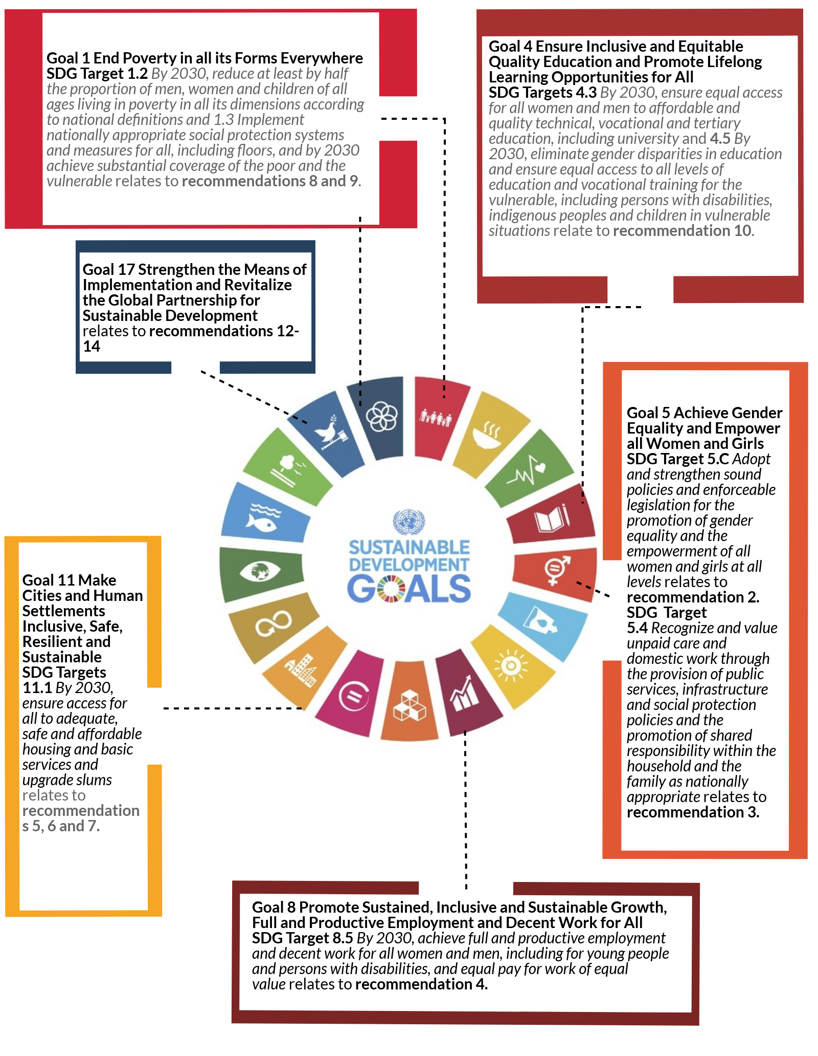

Reference List
ABC Q&A (2017). ABC QANDA In the House Facebook Live. [video] Available at: https://www.facebook.com/abcqanda/videos/vb.13545876830/10154600357366831/?type=2&theater [Accessed 4 Dec. 2017].
Allebone, J. (2011). Valuing care in Australia Achieving pay equity in the social and community services sector. Social Policy Working Paper. [online] Melbourne: Brotherhood of St Laurence and The Centre for Public Policy, p.4. Available at: http://library.bsl.org.au/jspui/bitstream/1/2500/1/Allebone_Valuing_care_achieving_pay_equity_2011.pdf [Accessed 4 Dec. 2017].
Anglicare Australia (2017). Rental Affordability Snapshot 2017. Rental Affordability Snapshot Series. [online] Available at: http://www.anglicare.asn.au/docs/default-source/default-document-library/rental-affordability-snapshot-2017.pdf?sfvrsn=4
Australian Bureau of Statistics (2014). 6333.0 - Characteristics of Employment, Australia, August 2014. [online] Available at: http://www.abs.gov.au/AUSSTATS/abs@.nsf/Lookup/6333.0Main+Features1August%202014?OpenDocument [Accessed 9 Dec. 2017].
Australian Bureau of Statistics (2012). 6224.0.55.001 - Labour Force, Australia: Labour Force Status and Other Characteristics of Families, Jun 2012. [online] Available at: http://www.abs.gov.au/ausstats/abs@.nsf/Products/6224.0.55.001~Jun%202012~Chapter~one%20Parent%20Families [Accessed 9 Dec. 2017]
Australian Council of Social Service (ACOSS) (2015). Fuel on the Fire: negative gearing, capital gains tax and housing affordability. Tax Talks 2. [online] Available at: http://www.acoss.org.au/images/uploads/Fuel_on_the_fire.pdf [Accessed 1 Dec. 2017].
Australian Council of Social Service (ACOSS) (2016). Poverty in Australia. Poverty and Inequality in Australia. [online] p.32. Available at: http://www.acoss.org.au/wp-content/uploads/2016/10/Poverty-in-Australia-2016.pdf [Accessed 23 Nov. 2017]
Australian Health Ministers’ Advisory Council (AHMAC) (2016) Final report on the National Maternity Services Plan 2010-2015. [online] Australian Government. Available at: http://www.coaghealthcouncil.gov.au/Publications/Reports [Accessed 4 Dec. 2017]
Affordable Housing Work Group (2017). Supporting the Implementation of an Affordable Housing Bond Aggregator. [online] Australian Government. p.19. Available at: https://static.treasury.gov.au/uploads/sites/1/2017/09/170921-AHWG-final-for-publication.pdf [Accessed 1 Dec. 2017]
Australian Government (2017). Towards 2025 An Australian Government Strategy to Boost Women’s Workforce Participation. [online] p.18. Available at: http://womensworkforceparticipation.pmc.gov.au/sites/default/files/towards-2025-strategy.pdf [Accessed 9 Dec. 2017].
Australian Housing and Urban Research Institute (AHURI). (2017). Does building more houses fix affordability for low-income households?. [online] Available at: https://www.ahuri.edu.au/policy/ahuri-briefs/does-building-more-houses-fix-affordability-for-low-income-households [Accessed 5 Dec. 2017].
Australian Institute of Health and Welfare (AIHWc) (2017). Australia’s mothers and babies 2015 – in brief. Perinatal statistics series no. 33 [online] Commonwealth Government. Available at: https://www.aihw.gov.au/reports/mothers-babies/australias-mothers-babies-2015-in-brief/contents/table-of-contents
Australian Institute of Health and Welfare (AIHWa) (2017). Housing Assistance in Australia 2017. [online] Commonwealth Government. Available at: https://www.aihw.gov.au/reports/housing-assistance/housing-assistance-in-australia-2017/contents/social-housing-tenants [Accessed 5 Dec. 2017].
Australian Institute of Health and Welfare (AIHWb) 2017). Specialist Homelessness Services Annual Report 2016-17. [online] Commonwealth Government. Available at: https://www.aihw.gov.au/reports/homelessness-services/specialist-homelessness-services-2016-17/contents/contents [Accessed 15 Dec. 2017].
Bankwest Curtin Economics Centre (BCEC) (2015). The Ripple Effect of Poverty – Causes and Consequences of Poverty in Australia. [online] Available at: http://chp.org.au/wp-content/uploads/2015/10/151027-CEDA-Ripple-Effect-of-Poverty-Anti-Poverty-Week-2015.pdf [Accessed 14 Dec. 2017]
Committee for Economic Development Australia (CEDA) (2017). Housing Australia. [online] Melbourne, pp.28-30. Available at: https://www.ceda.com.au/CEDA/media/General/Publication/PDFs/HousingAustraliaFinal_Flipsnack.pdf [Accessed 9 Dec. 2017].
Daley, J. and Wood, D. (2016). Hot Property - Negative Gearing and Capital Gains Tax Reform. [online] Grattan Institute, p.2. Available at: https://grattan.edu.au/wp-content/uploads/2016/04/872-Hot-Property.pdf [Accessed 1 Dec. 2017].
Department of Foreign Affairs and Trade (DFAT). (2016). Gender equality and women’s empowerment strategy. Australian Government. Available online: http://dfat.gov.au/about-us/publications/documents/gender-equality-and-womens-empowerment-strategy.pdf
Department of Foregin Affairs and Trade (DFAT). (2017). Performance of Australian Aid 2015-16. Australian Government. p. 92. http://dfat.gov.au/about-us/publications/Documents/performance-of-australian-aid-2015-16.pdf
Department of Health and Ageing (DHS) (2011). National Maternity Services Plan. [online] Australian Government. Available at : http://www.health.gov.au/internet/main/publishing.nsf/Content/maternityservicesplan [Accessed at: 4 Dec. 2017]
Department of Social Services (DSS) (2012). Australian National Action Plan on Women, Peace and Security 2012-2018. Commonwealth Government. Available online: https://www.dss.gov.au/sites/default/files/documents/05_2012/aus_nap_on_women_2012_2018.pdf
Department of Social Services (DSS) (2017). DSS Demographics March 2017. [online] Commonwealth Government. Available at: https://data.gov.au/dataset/dss-payment-demographic-data/resource/adbe8196-5669-4f33-b01a-65b04ad41b55 [Accessed 4 Dec. 2017].
Department of Social Services (DSS) (2016). Third Action Plan 2016-2019. The National Plan to Reduce Violence against Women and their Children 2010-2022. [online] Australian Government, p.19. Available at: https://www.dss.gov.au/sites/default/files/documents/10_2016/third_action_plan.pdf [Accessed 4 Oct. 2017].
Family and Community Development Committee (2017). Inquiry into perinatal services. [online] Parliament of Victoria. Available at: https://www.parliament.vic.gov.au/fcdc/inquiries/inquiry/422. [Accessed 4 Dec. 2017]
Flatau, P., Zaretzky, K., valentine, k., McNelis, S., Spinney, A., Wood, L., MacKenzie, D. and Habibis, D. (2017). Inquiry into funding and delivery of programs to reduce homelessness. [online] Melbourne: AHURI, p.4. Available at: https://www.ahuri.edu.au/__data/assets/pdf_file/0023/12893/AHURI_Final_Report_No279_Inquiry-into-funding-and-delivery-of-programs-to-reduce-homelessness.pdf [Accessed 3 Dec. 2017].
Gender and Development Network. (2015). Turning Promises into Progress: Gender equality and rights for women and girls - lessons learnt and actions needed. http://gadnetwork.org/turning-promises-into-progress/
Haynes, J. (2017). Household Expenditure Survey: How to save on the big expenses. ABC News. [online] Available at: http://www.abc.net.au/news/2017-09-13/how-to-save-on-household-expenses/8936088 [Accessed 23 Nov. 2017].
Hudson, V, et al. (2012) Sex & World Peace, New York, Columbia University Press
International Labour Organisation. (2012) Global Estimate of Forced Labour, Available online: http://www.ilo.org/global/topics/forced-labour/publications/WCMS_182004/lang--en/index.htm
Joint Standing Committee on Foreign Affairs, Defence and Trade (2017) Modern slavery and global supply chains, Parliament of Australia Available online: https://www.aph.gov.au/Parliamentary_Business/Committees/Joint/Foreign_Affairs_Defence_and_Trade/ModernSlavery/Interim_Report
Kelly, J. (2013). Renovating Housing Policy. [online] Grattan Institute. Available at: https://grattan.edu.au/report/renovating-housing-policy/ [Accessed 1 Dec. 2017].
Feldman, S. and Radermacher, H,. (2016). Time of our lives? Building opportunity and capacity for the economic and social participation of older Australian women. [online] Melbourne: Lord Mayor’s Charitable Foundation, p.13. Available at: https://www.lmcf.org.au/LMCF/media/05-Knowledge/PDFs/2016-03-07-LMCF-Time-of-Our-Lives-Report.pdf [Accessed 14 Dec 2017]
Melbourne Institute (2017). The Household, Income and Labour Dynamics in Australia Survey: Selected Findings from Waves 1 to 15.[online] p.32. Available at: http://melbourneinstitute.unimelb.edu.au/__data/assets/pdf_file/0010/2437426/HILDA-SR-med-res.pdf [Accessed 14 Dec. 2017]
Ng, C. (2015). Gender Responsive & Participatory Budgeting: Imperatives for Equitable Expenditure Switzerland: Springer International Publishing AG, p.2 and p.6.

Ruppanener, L. (2017). Census 2016: Women are still disadvantaged by the amount of unpaid housework they do. The Conversation. Available at: https://theconversation.com/census-2016-women-are-still-disadvantaged-by-the-amount-of-unpaid-housework-they-do-76008 [Accessed 9 Sep. 2017].
Sanders, J., and Bedford, M. (2017). New Minimum Income for Healthy Living Budget Standards for Low-Paid and Unemployed Australians Summary Report. [online] Sydney: Social Policy Research Centre UNSW, p. 8. Available at: http://unsworks.unsw.edu.au/fapi/datastream/unsworks:46141/binaaacbcf3-915f-40bc-a70f-2052746ab643?view=true
Senate Economics References Committee (2015). Out of Reach? The Australian Housing Affordability Challenge. Parliament of Australia, p.405
Senate Economics References Committee (2016). ‘A Husband is Not a Retirement Plan’ Achieving Economic Security for Women in Retirement. Parliament of Australia, p. 126
Senate Finance and Public Administration Committee (2017). Gender segregation in the workplace and its impact on women's economic equality. Parliament of Australia, p.12 and p.33

Senate Standing Committee on Community Affairs (2014). Bridging our growing divide: inequality in Australia. The extent of income inequality in Australia. Parliament of Australia, p. xxi
Senate Standing Committee on Community Affairs (2017). Answers to Estimates Question on Notice. Health Portfolio. Budget Estimates 2017-2018 Ref No: SQ17-000604. Parliament of Australia
Senate Community Affairs Legislation Committee (2017). Senator Waters questions Department of Health on maternity services, Tuesday 30 May 2017. [video] Available at: https://www.youtube.com/watch?v=vq94xcH0n8s&sns=fb [Accessed 4 Dec. 2017].
Tomar, R., (2016) The ever-shrinking aid budget: Budget Review 2015–16. Canberra: Parliamentary Library. Available at: https://www.aph.gov.au/About_Parliament/Parliamentary_Departments/Parliamentary_Library/pubs/rp/BudgetReview201516/Aid
Tually, S., Slatter, M., Faulkner, D. and Oakley, S. (2017). The role of private rental brokerage in housing outcomes for vulnerable Australians. [online] Adelaide: AHURI, p.4. Available at: https://www.ahuri.edu.au/__data/assets/pdf_file/0014/8150/AHURI_Final_Report_No263_The-role-of-private-rental-brokerage-in-housing-outcomes-for-vulnerable-Australians.pdf [Accessed 1 Dec. 2017].
UN Women (2014), Slavery in Australia – A Silent Crime, available at https://unwomen.org.au/slavery-in-australia-a-silent-crime/
Workplace Gender Equality Agency (2016). Gender Segregation in Australia's Workforce. [online] pp.4 and 5. Available at: https://www.wgea.gov.au/sites/default/files/20160801_Industry_occupational_segregation_factsheet.pdf [Accessed 3 Dec. 2017].

Indicator 5.C.1 of SDGs is Proportion of countries with systems to track and make public allocations for gender equality and women’s empowerment
The Senate Standing Committee on Economics Report “A Husband is Not A Retirement Plan” recommended that the issue of effective marginal tax rates for second earners be referred to the Productivity Commission, noting the significance of women’s workforce participation.
See the 2017-18 Pre-Budget Submission from economic Security 4 Women for further information.

